**Aggregate functions in SQL**

* SQL aggregation function is used to perform the calculations on multiple rows of a single column of a table. It returns a single value.
* It is also used to summarize the data.

## **Types of SQL Aggregation Function**

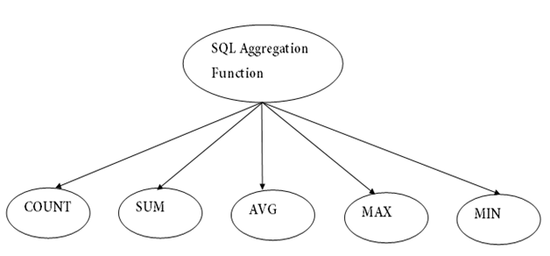

**Various Aggregate Functions**

1) Count()

2) Sum()

3) Avg()

4) Min()

5) Max()

Now let us understand each Aggregate function with a example:

Id Name Salary

-----------------------

1 A 80

2 B 40

3 C 60

4 D 70

5 E 60

6 F Null

**Count():**

***Count(*):*** Returns total number of records .i.e 6.  
***Count(salary):*** Return number of Non Null values over the column salary. i.e 5.  
***Count(Distinct Salary):*** Return number of distinct Non Null values over the column salary .i.e 4

**Sum():**

***sum(salary):*** Sum all Non Null values of Column salary i.e., 310  
***sum(Distinct salary):*** Sum of all distinct Non-Null values i.e., 250.

**Avg():**

***Avg(salary)*** = Sum(salary) / count(salary) = 310/5  
***Avg(Distinct salary)*** = sum(Distinct salary) / Count(Distinct Salary) = 250/4

**Min():**

***Min(salary):***Minimum value in the salary column except NULL i.e., 40.  
***Max(salary):***Maximum value in the salary i.e., 80.

### **1. COUNT FUNCTION**

* COUNT function is used to Count the number of rows in a database table. It can work on both numeric and non-numeric data types.
* COUNT function uses the COUNT(*) that returns the count of all the rows in a specified table. COUNT(*) considers duplicate and Null.

**Syntax**

1. ]
2. or
3. COUNT( [ALL|DISTINCT] expression )

**Sample table:**

**PRODUCT_MAST**

|  |  |  |  |  |
| --- | --- | --- | --- | --- |
| **PRODUCT** | **COMPANY** | **QTY** | **RATE** | **COST** |
| Item1 | Com1 | 2 | 10 | 20 |
| Item2 | Com2 | 3 | 25 | 75 |
| Item3 | Com1 | 2 | 30 | 60 |
| Item4 | Com3 | 5 | 10 | 50 |
| Item5 | Com2 | 2 | 20 | 40 |
| Item6 | Com1 | 3 | 25 | 75 |
| Item7 | Com1 | 5 | 30 | 150 |
| Item8 | Com1 | 3 | 10 | 30 |
| Item9 | Com2 | 2 | 25 | 50 |
| Item10 | Com3 | 4 | 30 | 120 |

**Example: COUNT()**

1. SELECT COUNT(*)
2. FROM PRODUCT_MAST;

**Output:**

10

**Example: COUNT with WHERE**

1. SELECT COUNT(*)
2. FROM PRODUCT_MAST;
3. WHERE RATE>=20;

**Output:**

7

**Example: COUNT() with DISTINCT**

1. SELECT COUNT(DISTINCT COMPANY)
2. FROM PRODUCT_MAST;

**Output:**

3

**Example: COUNT() with GROUP BY**

1. SELECT COMPANY, COUNT(*)
2. FROM PRODUCT_MAST
3. GROUP BY COMPANY;

**Output:**

Com1 5

Com2 3

Com3 2

**Example: COUNT() with HAVING**

1. SELECT COMPANY, COUNT(*)
2. FROM PRODUCT_MAST
3. GROUP BY COMPANY
4. HAVING COUNT(*)>2;

**Output:**

Com1 5

Com2 3

### **2. SUM Function**

Sum function is used to calculate the sum of all selected columns. It works on numeric fields only.

**Syntax**

1. SUM()
2. or
3. SUM( [ALL|DISTINCT] expression )

**Example: SUM()**

1. SELECT SUM(COST)
2. FROM PRODUCT_MAST;

**Output:**

670

**Example: SUM() with WHERE**

1. SELECT SUM(COST)
2. FROM PRODUCT_MAST
3. WHERE QTY>3;

**Output:**

320

**Example: SUM() with GROUP BY**

1. SELECT SUM(COST)
2. FROM PRODUCT_MAST
3. WHERE QTY>3
4. GROUP BY COMPANY;

**Output:**

Com1 150

Com2 170

**Example: SUM() with HAVING**

1. SELECT COMPANY, SUM(COST)
2. FROM PRODUCT_MAST
3. GROUP BY COMPANY
4. HAVING SUM(COST)>=170;

**Output:**

Com1 335

Com3 170

### **3. AVG function**

The AVG function is used to calculate the average value of the numeric type. AVG function returns the average of all non-Null values.

**Syntax**

1. AVG()
2. or
3. AVG( [ALL|DISTINCT] expression )

**Example:**

1. SELECT AVG(COST)
2. FROM PRODUCT_MAST;

**Output:**

67.00

### **4. MAX Function**

MAX function is used to find the maximum value of a certain column. This function determines the largest value of all selected values of a column.

**Syntax**

1. MAX()
2. or
3. MAX( [ALL|DISTINCT] expression )

**Example:**

1. SELECT MAX(RATE)
2. FROM PRODUCT_MAST;

30

### **5. MIN Function**

MIN function is used to find the minimum value of a certain column. This function determines the smallest value of all selected values of a column.

**Syntax**

1. MIN()
2. or
3. MIN( [ALL|DISTINCT] expression )

**Example:**

1. SELECT MIN(RATE)
2. FROM PRODUCT_MAST;

**Output:**

10